**\*\*\* This guide is done on a Mac with Python version 3.11, Django version 4.2 \*\*\***

**2.1 Create Virtual Environment and Django Project**

Check your python version:

python3 —version



Create a cs3300 and a portfolio folder in your location of choice:

**mkdir cs3300**

**cd cs3300**

**mkdir portfolio**

**cd portfolio**

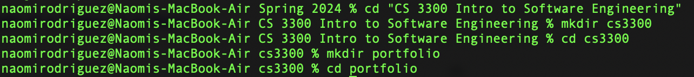

Create and activate virtual environment:

**python3 -m venv djvenv**

**source djvenv/bin/activate**

Install Django version 4.2 in virtual environment and confirm installation:

**pip install Django==4.2**

**python -m django —version**

Upgrade pip:

**python3 -m pip install —upgrade pip**

Create django project:

**django-admin startproject django_project**

Reformat the directory:

**mv django_project/manage.py ./**

**mv django_project/django_project**

**rm -r django_project/django_project/**

Should go from portfolio -> django_project, djvenv -> bin, include, etc…

Run server, ignore migration warnings:

**python manage.py runserver**

Check to see if installation worked by going to <http://localhost:8000/>

Open multiple terminal tabs

*\*\* Tip: \*\**

*- On Mac shortcut to open multiple tabs:*

*cmd-t*

*I had to recreate and activate venv:*

***python3 -m venv djvenv***

***source djvenv/bin/activate***

Display packages:

**pip list**

Create a requirements.txt file

**pip freeze > requirements.txt**

*Our team is using PyCharm, make sure you’ve been approved with your student license so you have full access to PyCharm’s features here:* [*https://www.jetbrains.com/community/education/#students*](https://www.jetbrains.com/community/education/#students)

In PyCharm go to File —> Open and open the Portfolio folder we created

**2.2 Create Local Git and Github Repository**